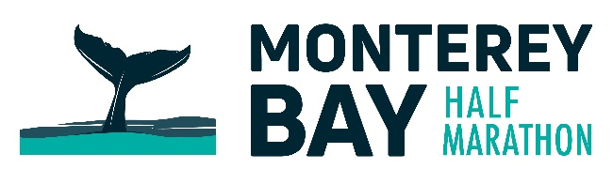

**MEDIA CONTACT:**

Hillary Fujii

Marketing Communications Manager

831.625.6226 or 831.915.3820

[hillary@bsim.org](mailto:hillary@bsim.org) • www.bsim.org

**Race Weekend Traffic and Parking Information**

The Monterey Bay Half Marathon weekend, November 9 and 10, will necessitate early morning street closures in the cities of Monterey and Pacific Grove.

The Sunday race begins at 6:50 AM on Del Monte Avenue at Camino El Estero, travels through downtown Monterey on Aguajito, Pearl, Alvarado, Franklin and Washington Streets, through the Lighthouse Tunnel, onto Cannery Row and along the Pacific Grove coastline with a loop through the downtown PG area. Runners return from Lovers Point along the Coastal Recreation Trail to the finish near Fisherman’s Wharf and Custom House Plaza.

**Pacific Grove**

Pacific Grove will be the location for three races – the Half Marathon on Monterey Bay, Sunday, November 10, and the shorter distance Pacific Grove Lighthouse 5K and By-the-Bay 3K, both on Saturday morning November 9. On-street parking will be restricted from 4 AM to 11 AM both days.

Saturday’s runs take place along the Pacific Grove coastline from Lovers Point with a turnaround at Point Pinos. Ocean View Blvd. between Lovers Point and Point Pinos will be closed from approximately 6 to 11 AM to accommodate the course set up and tear down.

On Sunday, the entire coastline of Pacific Grove will be closed to vehicle traffic between 6 and 11 AM. In addition, the Pacific Grove downtown area will be closed between 6 and 9:30 AM.

**Monterey**

Parking in downtown Monterey and the Cannery Row/New Monterey areas will be impacted between 2:00 AM and 11:00 AM on Sunday, November 10th. Many streets will be posted "No parking, tow away" in the event area.

Starting at 3:00 AM, many downtown city streets and the Monterey Bay Coastal Trail will be closed to facilitate the running of the half marathon. Traffic delays should be expected until 8:45 AM in the downtown area and until 11:00 AM in Cannery Row / New Monterey.

The Lighthouse Tunnel, both directions, will be closed from approximately 5:30 to 9:00 AM. Access to New Monterey/Cannery Row during these hours will be via Hwy. 1 and Hwy 68. Access to downtown Monterey from New Monterey and Pacific Grove will be via Lighthouse Avenue and the Pacific Street southbound extension.

All downtown city streets should be reopened by 9 AM. The Cannery Row area from the Coast Guard/San Carlos Beach area to the Monterey Bay Aquarium will be reopened at 11 AM.

* * *

Residents in all affected areas have been notified by letter from the Big Sur Marathon Foundation, the non-profit organization that directs the annual Monterey Bay Half Marathon.

For specific street closure information, please visit <http://www.montereybayhalfmarathon.org/traffic-information/>.